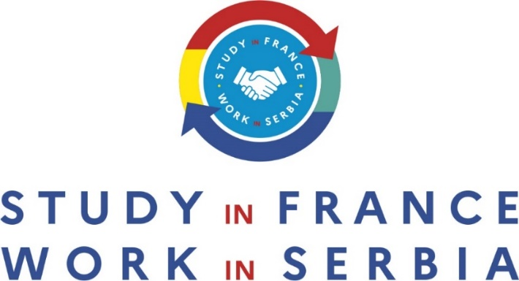

Studies and job opportunities in the cyber security sector
March 15th at the Rectorate of the University of Novi Sad - Zorana Đinđića 1

Agenda:
10:00 Registration & welcoming coffee
10:30 Introduction by the moderator, M. François-Xavier Kowandy, Technical / Academic / Scientific / Institutional Cooperation Attaché to the French Embassy in Serbia
10:40 Opening address by:
- Pr. Srđan Kolakovic, Dean of the Faculty of Technical Sciences University of Novi Sad (TBC)
- Mrs Marija Filipovic, Director of the Foundation Tempus
11:00 M. Cédric Grousset, Director of studies, Western Balkans Cyber Capacity Centre: Presentation of the Institute
11:20 M. Vincent Guiltat, University of Bretagne Sud, Project Manager at the International Affairs Department and in charge of the Erasmus Mundus Joint Master CYBERUS
11:40 M. Aurélien Francillon, professor in the System and Software Security > (S3) group of the security department at EURECOM France.
12:00 PANEL moderated by M. François-Xavier Kowandy with:
M. Darko Calasan, Head of Cyber Security at Atos Serbia: focus on HR needs in Cyber
Security sector in Serbia
M. Imre Lendak, professor, Faculty of Technical Sciences University of Novi Sad: focus on Serbian cybersecurity challenge
M. Nicolas Rabrenovic, President of French Tech Belgrade and EDDA CTO: focus on the needs for IT sector companies to include cybersecurity challenges for its development in Serbia and Europe
12:45 Q&A session between students and panellists
13:00 Networking lunch
14:30 End of the event

Panel Speakers:

Darko Calasan - Head of Cyber Security at Atos Serbia

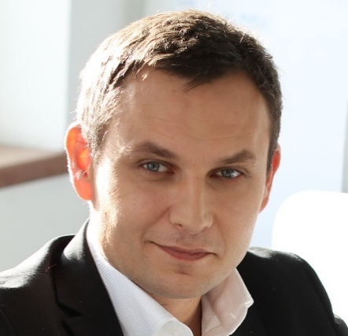
More than 15 years of experience in Information Security and Cyber Security in foreign companies and financial institutions. Responsible for the creation of all lines of prevention, defense, detection and control mechanisms, risk analysis and implementation of international information security standards, domestic information security law, personal data protection law (GDPR), Cyber Security strategy and good practices, and everything related to minimizing the risk of cyber security incidents.
Also, wide experience in team-led for the implementation of world wide technology leaders in the field of cyber security solutions, as well as conducting security testing of ICT infrastructure.

Vincent Guiltat - Project Manager for Erasmus Mundus Joint Master CYBERUS
at University of Bretagne Sud

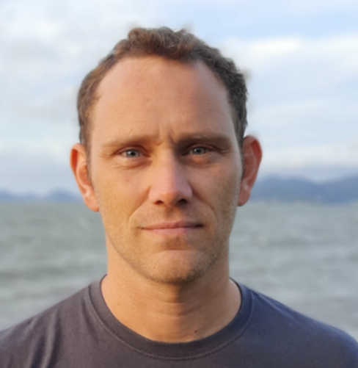
Vincent has experience as a project manager in France and abroad. He has coordinated several international solidarity projects in Africa with French and European funding. At the University of Bretagne Sud, he is in charge of the administrative coordination of the Master Erasmus Mundus CYBERUS within the International Affairs Department and of the management of the European funding for this master.

Nicolas Rabrenovic - President of French Tech Belgrade and EDDA CTO
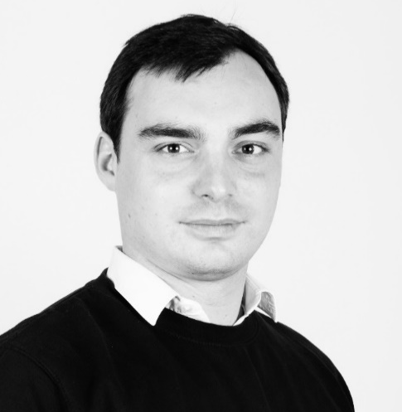
Nicolas is a graduate of the WebSchoolFactory and of HETIC. He is co-founder and CTO of the startup Kushim, which creates financial software for the venture capital and private equity sector. A serial entrepreneur, Nicolas has been working in the digital and new technologies sector since 2012 and has already co-created 5 companies. He is a mentor at Creatis, the residence for culture and media entrepreneurs. Since 2019, he is the president of the French Tech Belgrade community.

Aurélien Francillon – Professor in the System and Software Security > (S3)
Security Department at EURECOM

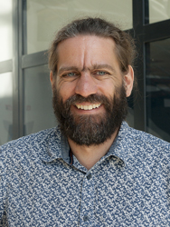
Aurélien Francillon is a professor in the System and Software Security > (S3) group of the security department at EURECOM (France). Before this he received PhD degree (2009) from INRIA and Grenoble INP, then he was a postdoctoral researcher in the System Security Group at ETH Zurich. He is mainly interested in practical aspects of the security of embedded devices. In this context, he has worked on topics such as software security testing, reverse engineering, wireless security, attestation, hardware support for software security, as well as on broader security and privacy topics. His work was often covered in the general press, such as "Le Monde", MIT Technology review or CSO Online. More than 10 PhD students are currently under his supervision or already graduated. He is the author of over 50 publications in international conferences. He has been regularly publishing and being a PC member of his field's top conferences. At the national level, he is involved in the GDR sécurité Informatique as a work group co-chair and creator of GDR's PhD award which he chaired for 3 years. He is also a member of the scientific committee of the ANSSI (French National Cybersecurity Agency).

Imre Lendak – Professor at Novi Sad faculty of technical science

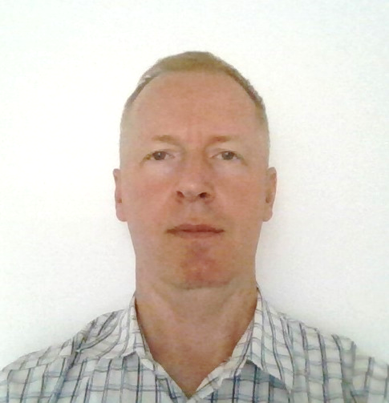
Imre Lendak is an Associate Professor teaching Critical infrastructure security, applied cryptography and cryptoanalysis, Security data science and Distributed systems and algorithms at the Faculty of Technical Science (FTN), University of Novi Sad, Serbia. His main research and professional interest is critical infrastructure/industrial control system security. He coordinated the EU-funded Information Security Services Education in Serbia (ISSES) project in the 2017-2021 period. Key project results include the development of new information security and digital forensics laboratories, MSc study programs and 13 cybersecurity courses at key Serbian higher education institutions. Imre Lendak is the head of the Information Security Laboratory at the FTN which was founded in 2019 as part of the ISSES project. He is a member of the Program Committee of the Serbian Cybersecurity Challenge (SCC) national competition for university and high school students, which was started in 2020. He was the recipient of the Balkans Cybersecurity Fellowship 2021 awarded by CRDF Global
Moderator:
François-Xavier Kowandy – Attaché at the French Embassy in Serbia

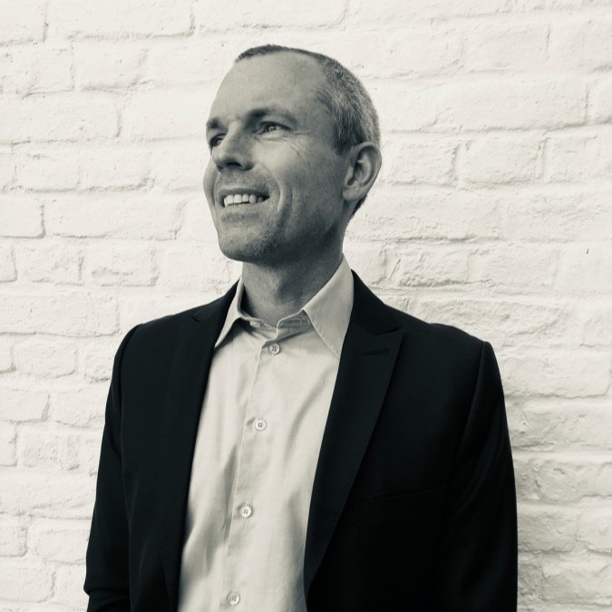
François-Xavier has studied Political sciences at the University of Lille and obtained M2 in European policies from the Science Po Strasbourg. His fields of specialization are environment, innovation, and valorization of research.
He is currently responsible for scientific, technical, and university cooperation at the Embassy of France in Serbia.
He has created the Serbian – French innovation forum which gathers students, researchers and Startuppers and foster cooperation in key economic sectors for Serbia and France.
He has also created the “Study in France- Work in Serbia program” and the Environmental national contest – Ekoopstina- for local authorities and schools.

