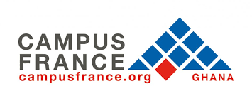

Are you a Ghanaian? Have you ever studied in France? This is your chance to become a member of the first ever network of Ghanaian students who studied in France!
FRANCE ALUMNI GHANA!!!

Why Should You Sign Up?
- Discover a broad network of current and past students and professionals in diverse fields. Whatever your area of interest or expertise may be, you’re sure to find someone with whom you can link up and share ideas
- Get informed on the latest economic, cultural and social trends in France
- Get updates on job offers, internships and other opportunities to aid your career development
- Schools and companies can keep abreast with activities and developments of partner institutions abroad

You can become a member by registering on the website
And it’s absolutely free!
Simply click on the following link: www.ghana.francealumni.fr

Who Else Can Join The Platform?
- Students of the Alliances Françaises and the Lycée Jacques Prévert are very much welcome.
- Educational institutions with vital interest in the French language or in building partnerships with fellow institutions or students in France.
- Organisations in Ghana that are looking to reach an extensive base of French-speaking people with international experience.
- French and local companies in Ghana interested in having access to a database of multicultural institutions and alumni for prospective job, internship, academic or partnership opportunities.
GET YOUR HANDS ON A BRAND NEW TABLET!!!!!
There will be a special raffle draw for the first 100 alumni to register on the platform from 10th of April till the 31st of May. The lucky winner will receive an android tablet!!!
The platform will be officially launched in October 2017, in Accra.
Till then, stay tuned for more info!

