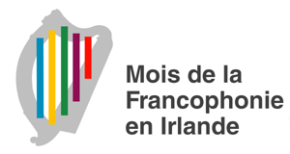
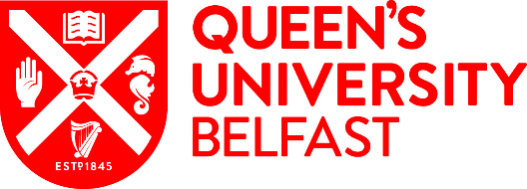
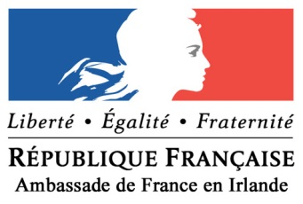
Irish Intervarsity Francophone Debates 2018
Queen’s University, Belfast – 23rd& 24th March
#IIFD2018 #SLFF18 #LoveQUBLangs
Welcome one and all to the second annual Irish Intervarsity Francophone Debates. On Friday 23rd and Saturday 24th March, the competition moves to Queen’s University, Belfast, after the fantastic inaugural event in Trinity College, Dublin last year. We are very excited to bring francophiles from across the island of Ireland in conjunction with the French Embassy in Ireland to celebrate the ‘Mois de la Francophonie enIrlande’.
This year, the debates will be centred on the theme of ‘oralité’, following the example of the French government’s annual initiative of ‘Dis-moi dix mots’, which this year is all about speaking. It is perfectly fitted to Joutes Oratoires. We look forward to welcoming you all to our corner of the Emerald Isle –we hope that you’ll enjoy the ‘Big Smoke’ as much as we do! We also encourage you to use the hashtags above to document, spread the word to your friends wanting to challenge their French, and to promote this event across social media!
This weekend will be a fantastic way of practising your spoken French, public speaking, and debating skills. It will also be a relaxed and social event which will allow you to interact with other students from across the island. Don’t worry if you think your French isn’t fluent – the main goal of the event is to have fun, and practice makes perfect! Marking will be based on the strength of your argument, rather than your ability in French. (Depending on numbers, we may be able to facilitate parallel novice rounds).
The intervarsity debating weekend will include:
- Three rounds of debates followed by a grand final. Should a novice level be feasible, the winners of this level will be announced after the three preliminary rounds. These rounds will be spread across Friday evening and Saturday morning and afternoon. The grand final will take place on Saturday afternoon.
- Dinner and a wine reception on Friday night, followed by a night out...

A potential novice round will be aimed at people who are less confident in speaking French. As such, it will consist of a reducedspeaking time per person (3 minutes). The advanced round is aimed at people who are confident in speaking French, and as such will consist of a longer speaking time (5-7 minutes)
Each team will consist of two members, with each round of debates consisting of four teams. Two teams will be for each motion, while two teams will be against it. Universities may enter as many teams of two as they wish; we have room for up to 16 teams in total. Although we encourage the participation of French natives, this year we have decided to limit their numbers to one native French speaker per team. The jury will also consequently be stricter on the development of arguments by French natives.
Following the theme of ‘oralité’, the motions for the three preliminary rounds are as follows:
- L’apprentissage des langues minoritaires vaut autant que celui d’une langue mondiale
- L’évolution d’une langue doit être encadrée.
- Les paroles s'envolent les écrits restent. (à l’heure du numérique)
The motion for the grand final will be announced an hour before it is due to begin.
Registration for the event will take place at 4pm on Friday 23rd March in the Main Site Tower (see figures 1 and 2 on the attached campus map). Registration will cost £15 per competitor, with a reduced fee of £10 for supporters and associates. This will cover food and drinks at the diner reception. All debates will take place in the MST or the adjoining Peter Froggatt Centre (PFC) or main Lanyon building. QUB is easily accessible by rail, bus, and road. The easiest route will be by bus to the Great Victoria Street/Europa depot, although please note that the cross-border train service (Enterprise) arrives into Belfast Central Station. Taxis and buses are quite reasonably priced. Please do let us know if you have any issues getting here.
€£ Don’t forget that as Northern Ireland is a part of the United Kingdom, you will need to exchange euros for pound sterling! €£
Our contact details are:
Email: french-society@qub.ac.uk
Twitter: @FrenchSocQUB
Facebook: https://www.facebook.com/qubfrenchsoc/
The event will finish on Saturday at 5pm. Unfortunately, QUB French Society is unable to provide accommodation for the event, but there are several well-priced establishments close by to the university that we would recommend, including:
- Holiday Inn Express Belfast City – Queen’s Quarter, 106A University Street
- Ibis Hotel Belfast Queen’s Quarter, 75 University Street
- ETAP Hotel Belfast, 35 Dublin Road
- Global Village Hostel, 97 University Street
- Belfast International Youth Hostel, 22-32 Donegall Road
- Lagan Backpackers, 121 Fitzroy Avenue
- Vagabonds Hostel, 9 University Road
- Belfast City Backpacker, 53-55 Malone Avenue
If you would not like to debate but would like to come along for the social side of things and support your university you are more than welcome.
Please fill out the following application form to help us get a better idea of numbers so that we can plan accordingly. The sooner you submit it the sooner we can tell you whether you are for or against the motions. Please submit this application form to french-society@qub.ac.uk before the 28th February.

IIFD 2018 Application Form
Name
Email Address
Phone Number (including international dialling code (+44/+353)
University
Course and year in that course
or
Position held in university
Please indicate preference for novice or advanced debates
Preferred teammate (if no preference we’ll assign you a teammate from your university cohort)
Please indicate if you will not be competing
Please indicate if you would like to adjudicate
Please indicate if you have any dietary requirements

