 | 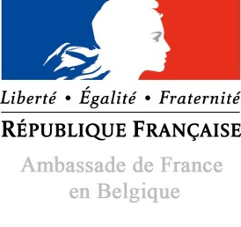  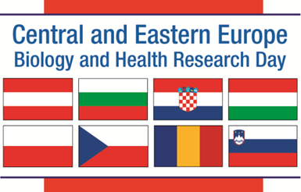 | REGISTRATION FORM  French-Central Eastern Europe  Brokerage Event  Paris , 22 MAY 2017  To be sent before 15 April 2017 to : votre email

INSTITUTION
Name of institution : |  |  | Acronym :
Address : |  |  | Website :
REPRESENTATIVES
1. | Last Name : | First Name : | Position:
 | Email : | Phone number :
 | Registration : 22 May 21 May – welcome dinner
2. | Last Name : | First Name : | Position:
 | Email : | Phone number :
 | Registration : 22 May 21 May – Welcome dinner
3. | Last Name : | First Name : | Position:
 | Email : | Phone number :
 | Registration : 22 May 21 May - welcome dinner
YOUR PROJECT - YOUR MAIN OBJECTIVES FOR COOPERATION (please check)
(European, H2020 or international project, research, teaching, student & staff exchange, joint programs…)

What do you do?

What do you offer?

What are you looking for?

